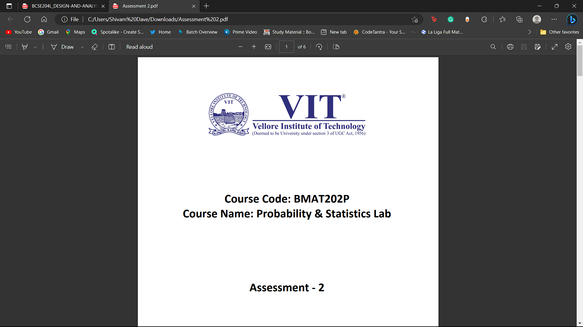 **Course Code: BCSE353E**

**Course Name: Information Security Analysis and Audit**

**Assessment – 1**

**Name: Shivam Dave**

**Reg. No.: 21BCB0107**

**Experiment 1: -**

**Designing a Network with 3 Desktop, 3 switches (2960) and 3 Routers (2811) as shown below and do the Network Trouble shooting using Packet Tracer Tool. Use the Network Commands using CLI options of the Cisco Packet Tracer.**

**Steps:**

1. First, we set up 3 PC PT 3 2811 and 2 2960-24TT routers as shown below

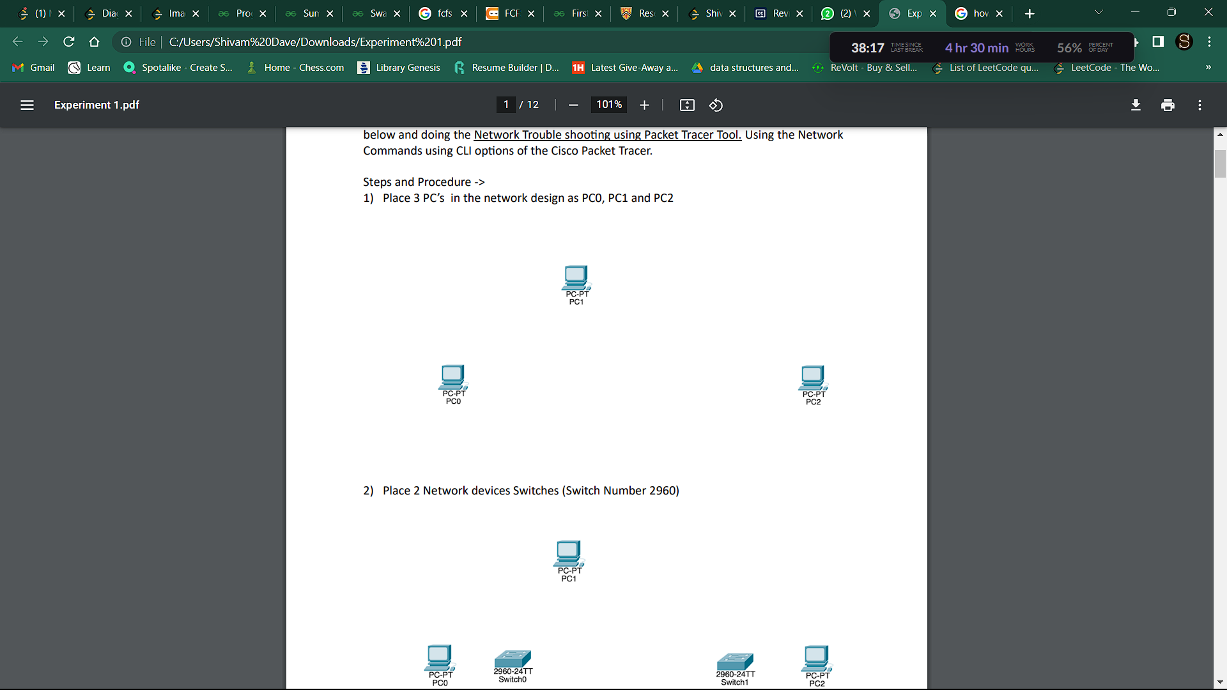

1. We connect with 2 network device Switches(Switch Number 2960)

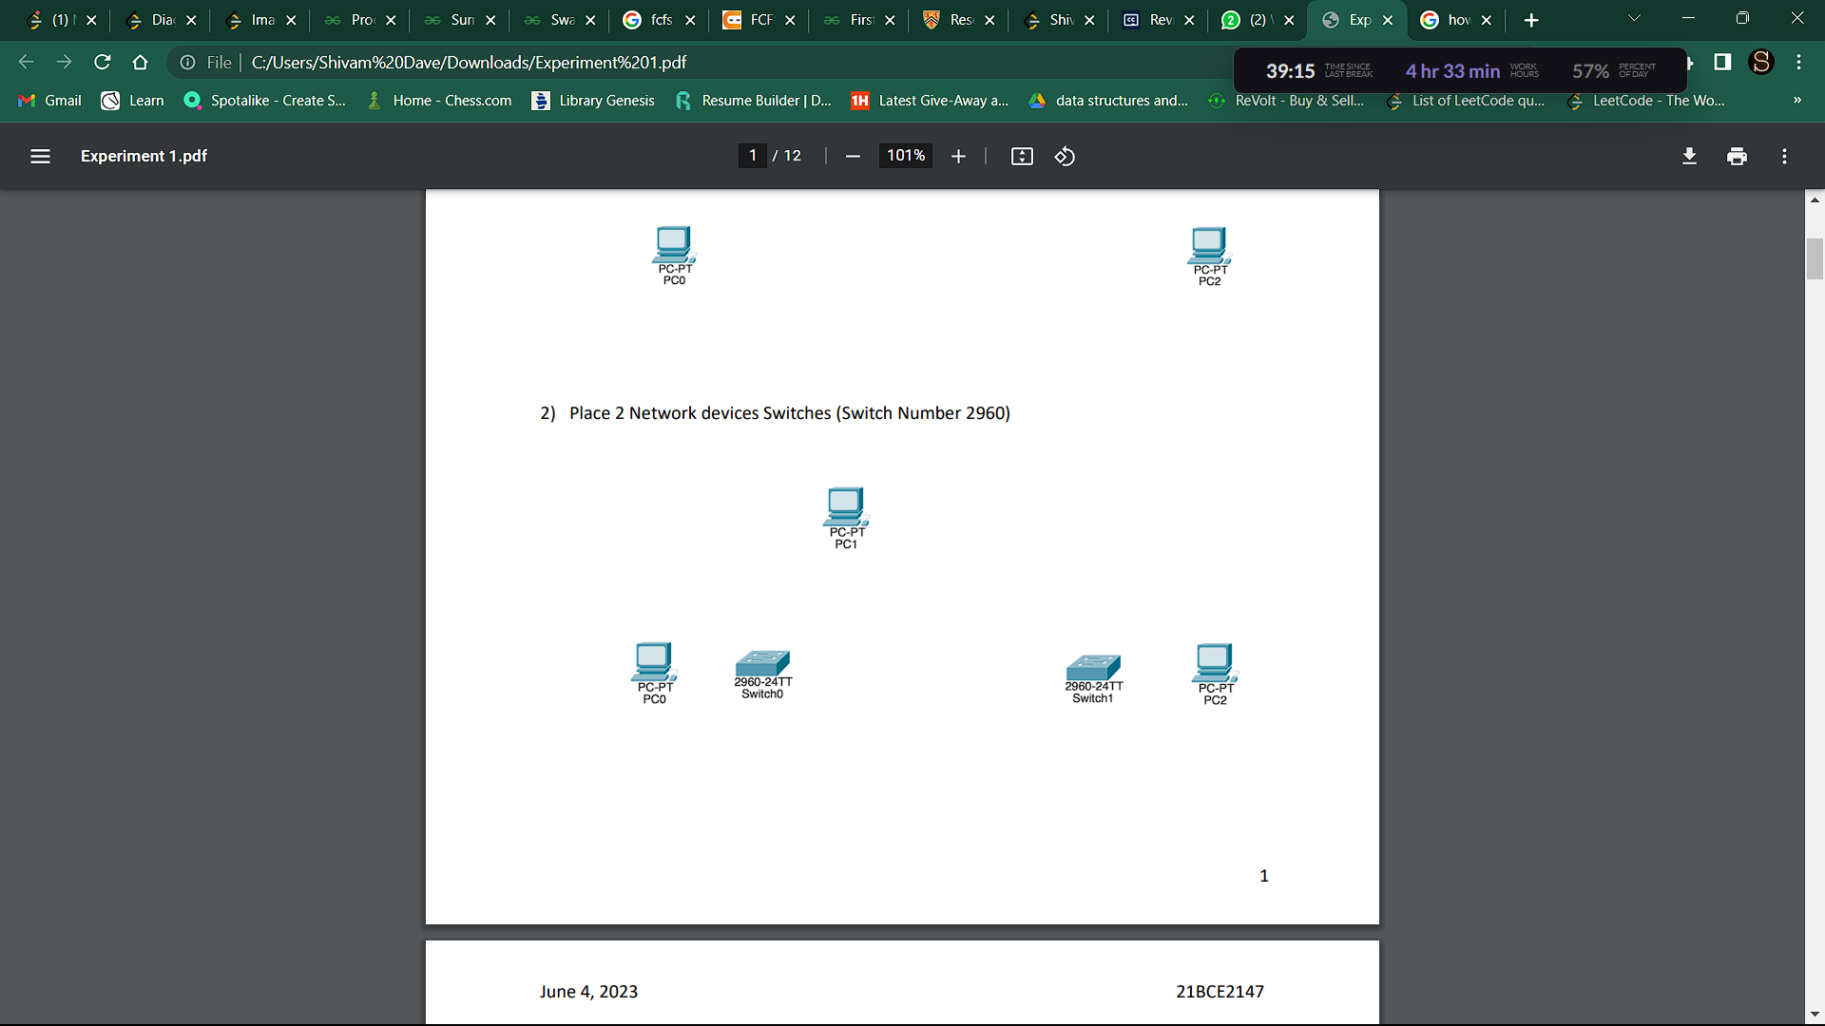

1. We place 3 routers (Router number 2811)

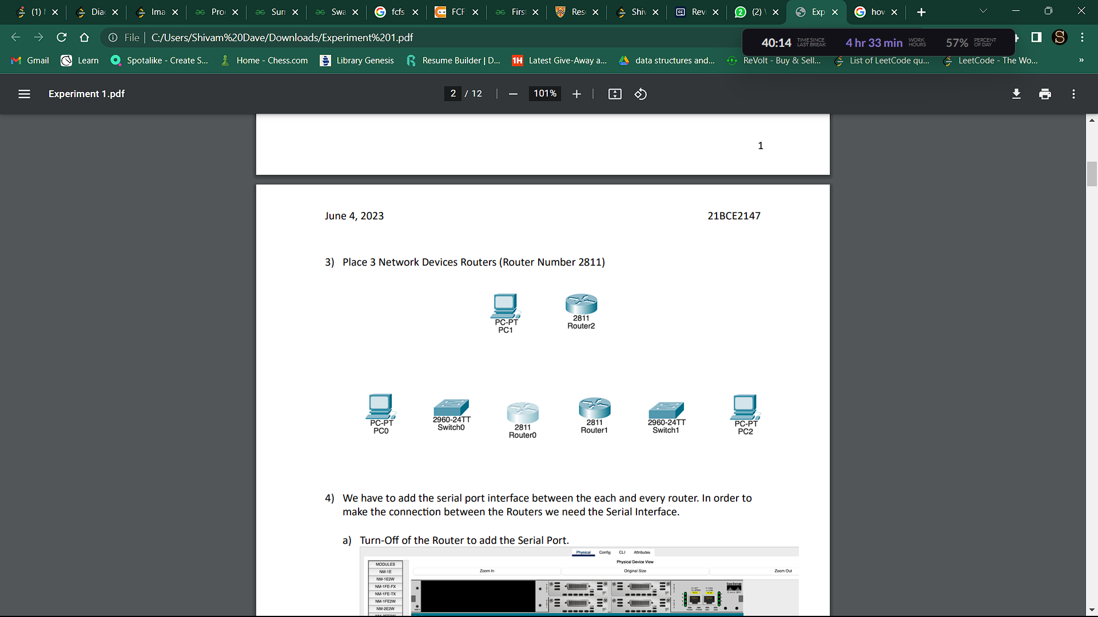

1. We need to make sure to add serial port interface to the given routers. It involves the following steps:
   1. Turn off the router to add serial port

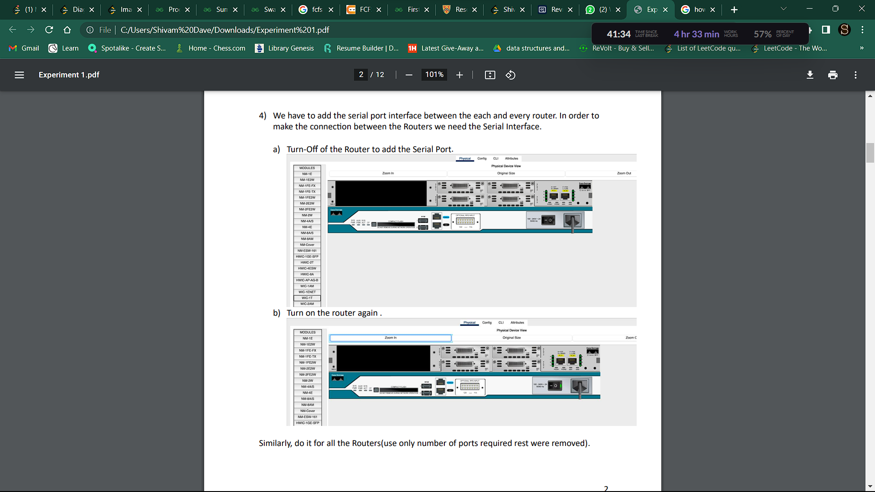

* 1. Turn on the router again.

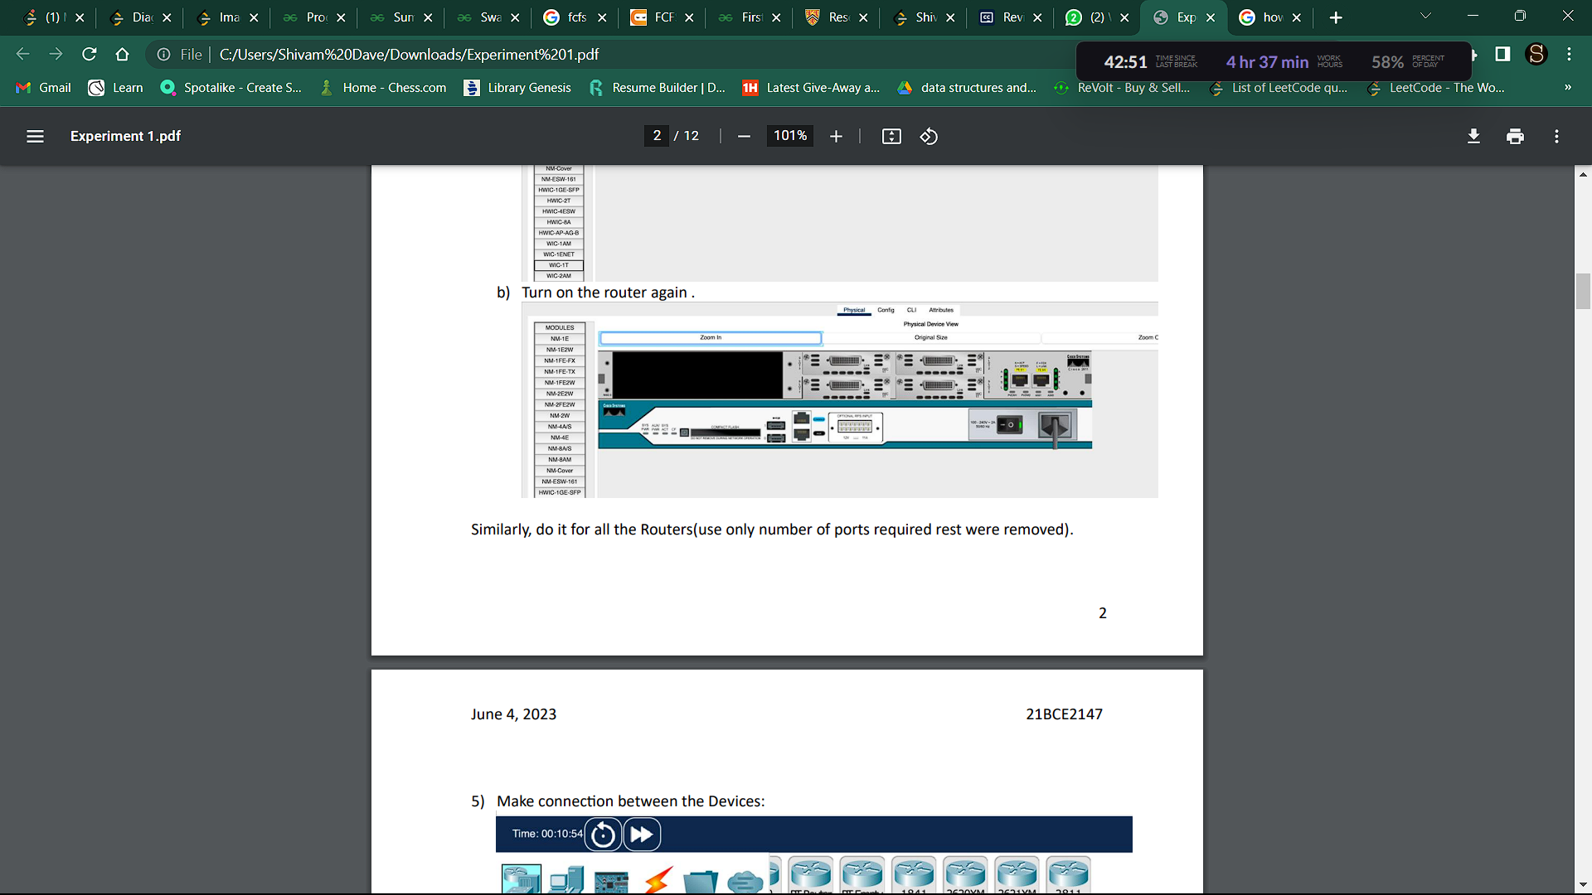

1. Make correct wire connections with each end device, network device and router as shown.
2. We finally create our circuit as follows: 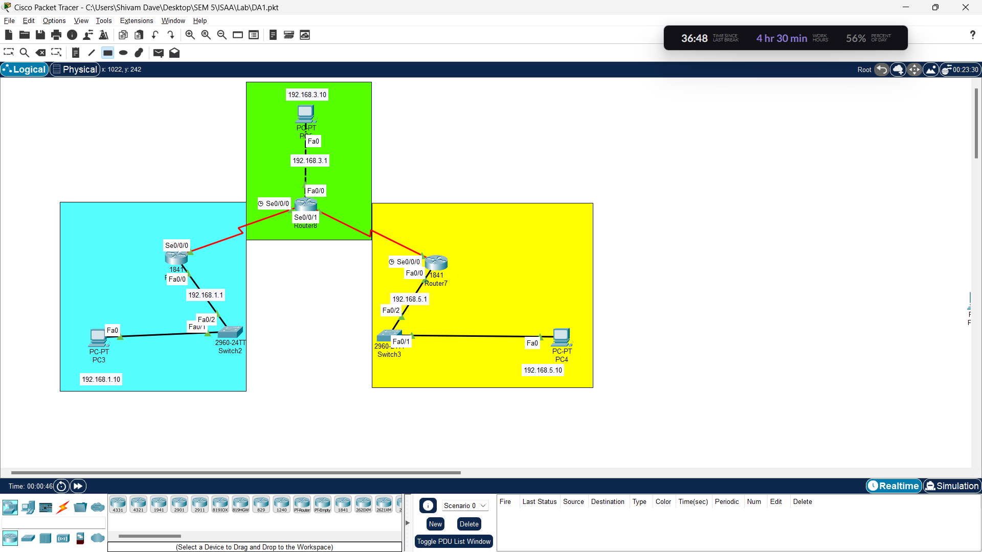

1. We configure the IP addresses of each PC

**For Router 1:**

CLI commands are as follows:

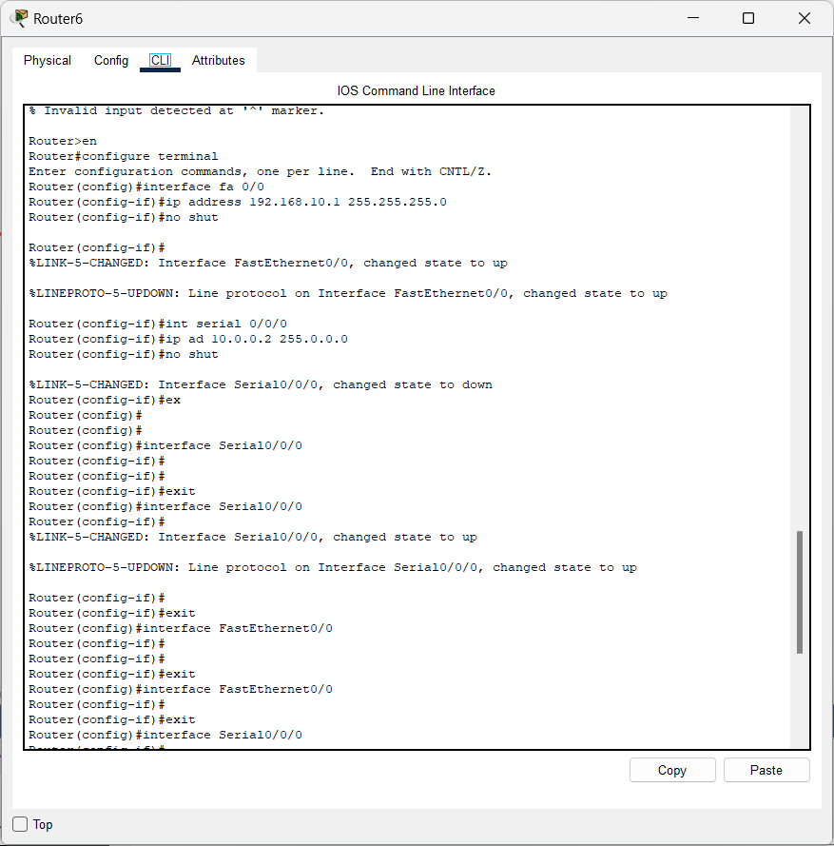

**For router 2:**

CLI commands are as follows:

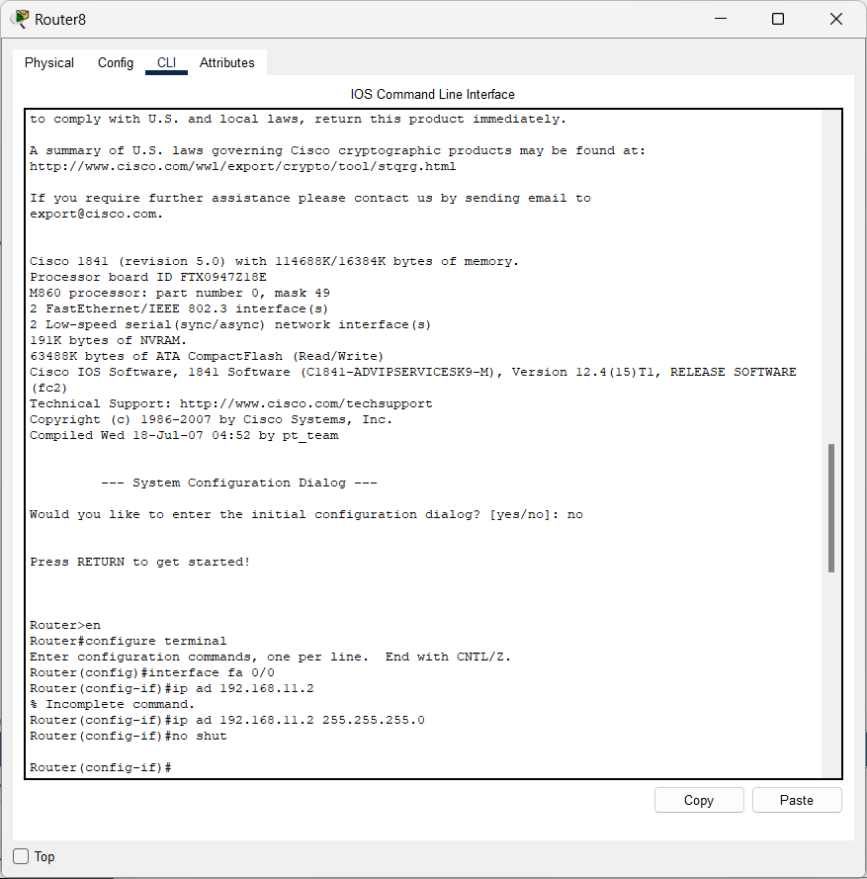

**For Router 3:**

IP V.4 Address is set as 13.10.10.10 for the PC-3 and default Gateway is set as 13.10.10.1

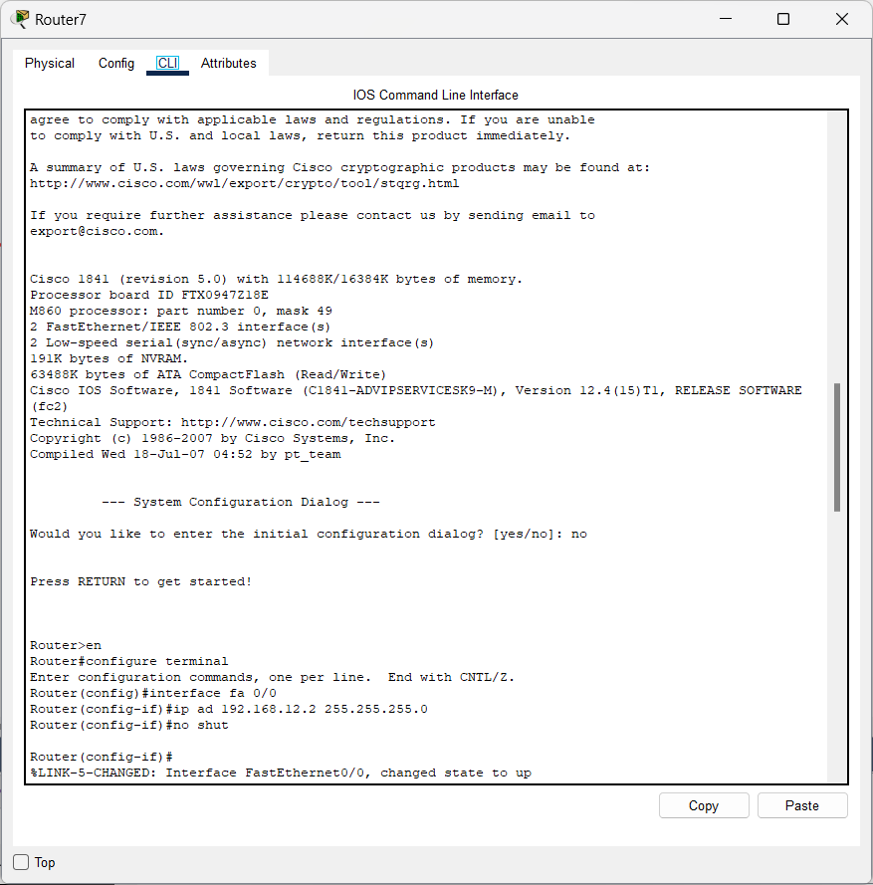

1. We configure the IP V.4 address of each router as follows:

**Router 1:**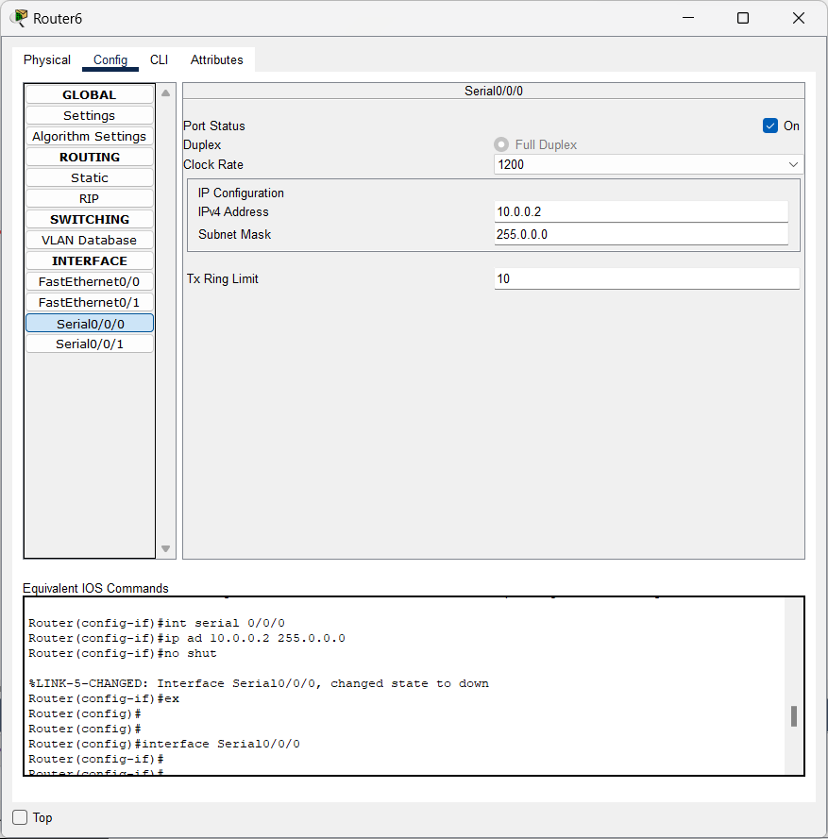

**Router 2:**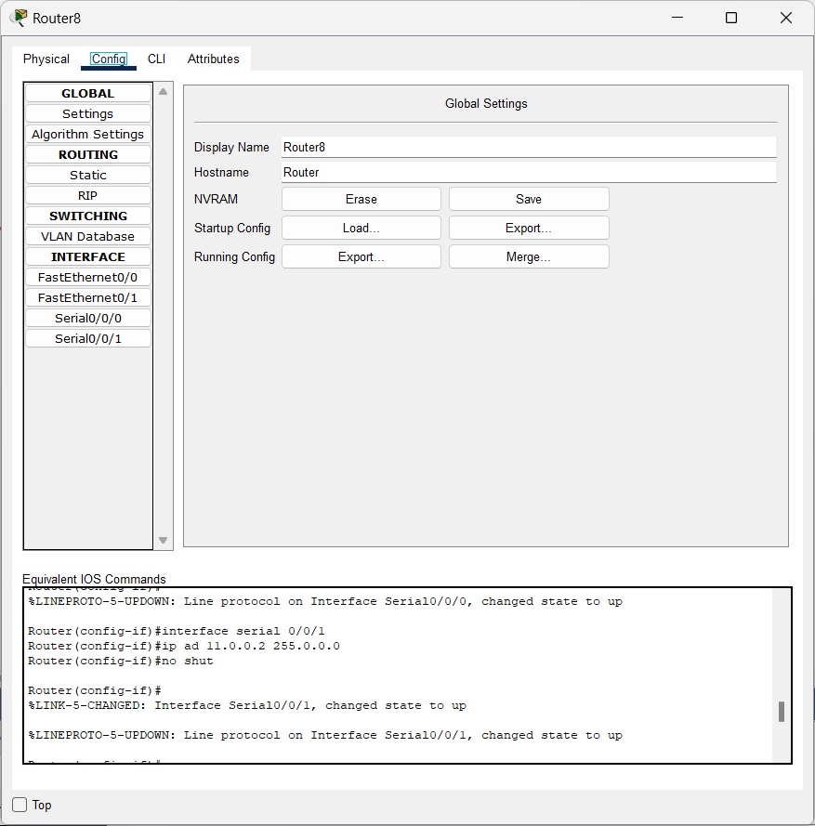

**Router 3:**

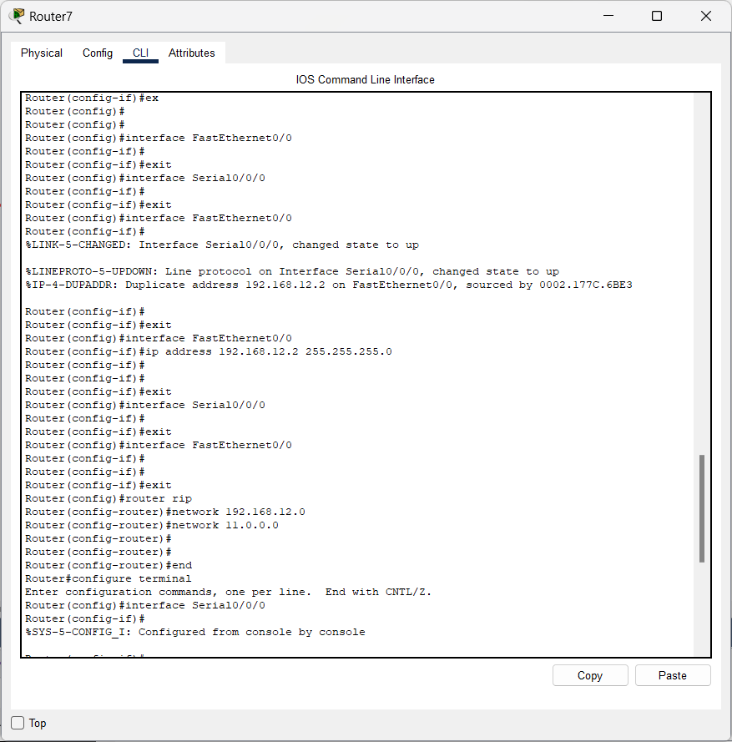

**Observation and results:**

Finally, after configuring everything. We use the Ping command to transmit data in form of Packets.

1. From PC0 to PC1 & PC2

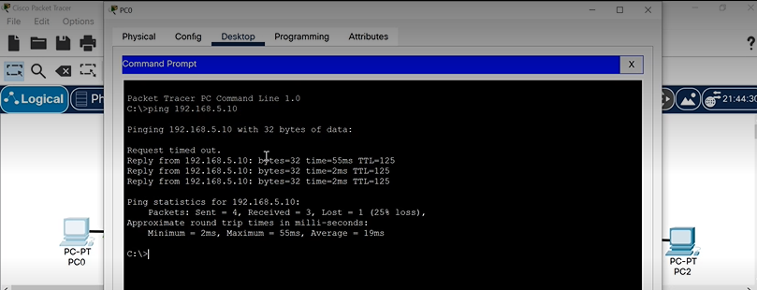

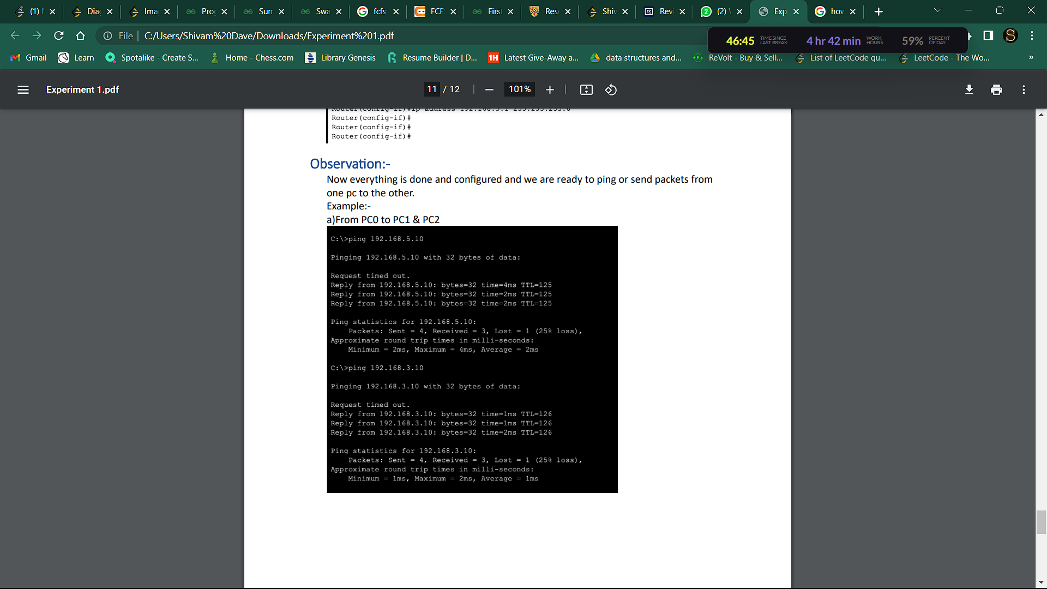

1. From PC1 to PC0 and PC2

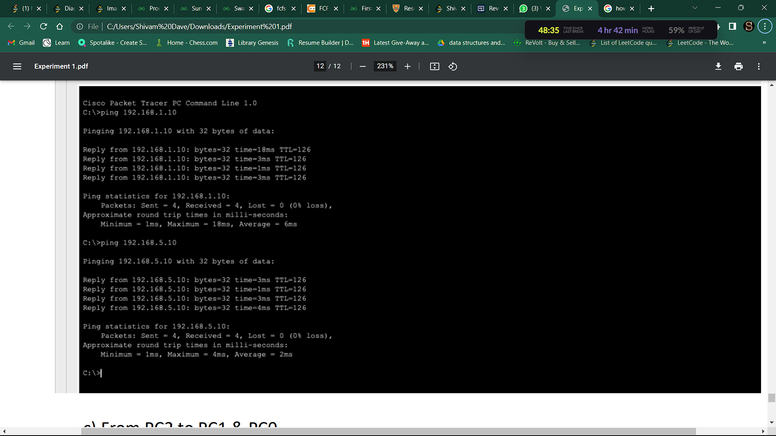

c) From PC2 to PC1 & PC0